FYI,

Thought for 4s
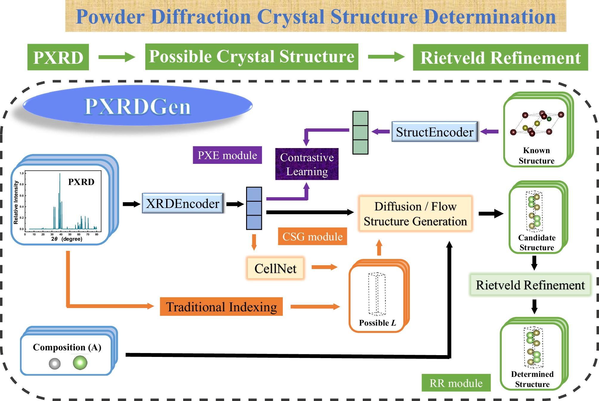
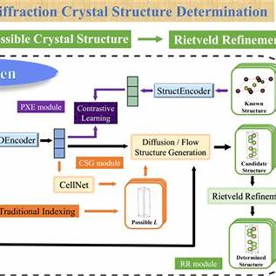
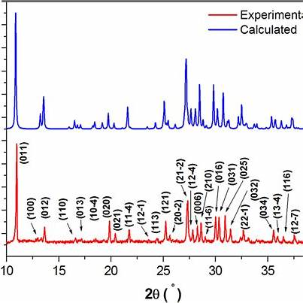
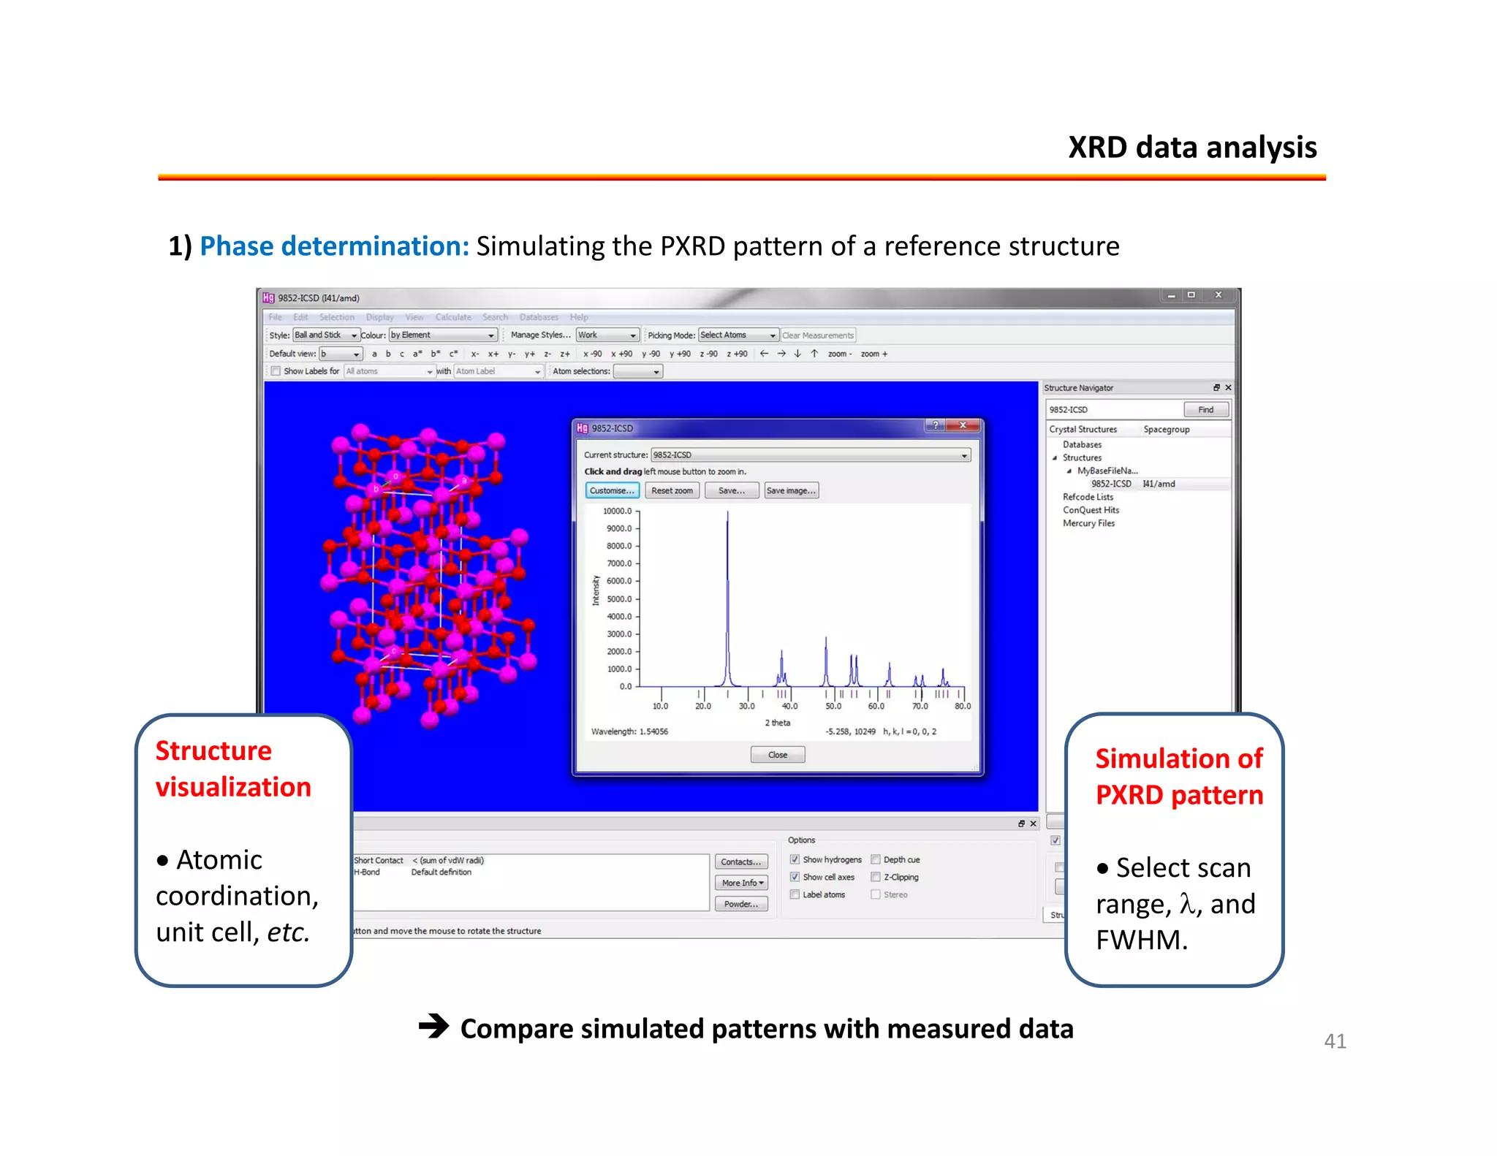
Here are a few useful images for the meeting deck / discussion:
- PXRDGen workflow figure — shows the full generative pipeline: PXRD input, XRD encoder, composition input, indexing/CellNet, diffusion or flow-based structure generation, candidate structures, and Rietveld refinement.
- PXRDGen candidate/reference structure schematic — similar source, but zoomed around the “known structure → candidate structures → determined structure” part of the workflow.
- Experimental vs calculated powder pattern example — useful for explaining how a proposed/calculated structure is validated against measured PXRD. It shows experimental and calculated/reference patterns overlaid or compared.
- Reference crystal structure + simulated PXRD pattern workflow — useful as a generic visual for “calculate pattern from known structure, then compare against measured data.”
For your specific meeting topic, I would use image 1 or 2 to illustrate the ML reverse-denoising / generative workflow, then image 3 to bridge back to the familiar crystallographic validation step: does the generated structure reproduce the measured powder pattern after refinement?
Do you have more information on the microsoft reverse de-noising approach
Thought for 6s
Yes. The Microsoft “reverse de-noising” approach is most likely MatterGen, from Microsoft Research / Microsoft AI for Science. It is related to the PXRD structure-solution methods we discussed, but with an important distinction:
MatterGen is primarily a crystal-structure generation / inverse materials-design model, not specifically a PXRD-conditioned structure-solution model. It generates inorganic crystal structures by reversing a noising/corruption process. PXRD-specific models such as XRDSol, PXRDGen, PXRDnet, and RealPXRD-Solver use a similar diffusion/denoising idea, but condition the generation directly on a measured or simulated powder pattern.
What Microsoft MatterGen does
MatterGen is a diffusion model for inorganic materials design. Microsoft describes it as a model for generating stable inorganic materials across the periodic table, with optional conditioning on desired chemistry, symmetry, mechanical, electronic, or magnetic properties.
The Nature paper describes the core process as follows: MatterGen generates stable materials by reversing a corruption process, iteratively denoising a random crystal structure. In the forward process, it corrupts three parts of the crystal representation: atom types, atomic coordinates, and the lattice. In the reverse process, an equivariant score network learns to jointly denoise those quantities.
Microsoft has also released an official GitHub implementation, describing MatterGen as a generative model for inorganic materials design that can be fine-tuned toward property constraints.
Conceptual workflow
The MatterGen workflow can be summarized like this:
- Represent a crystal structure
A crystal is represented by:
  - atom identities / species, usually denoted A
  - atomic coordinates, X
  - lattice parameters or lattice matrix, L
- Forward corruption / noising
During training, known stable structures from materials databases are deliberately corrupted. Atom types, coordinates, and lattice variables are pushed toward a noisy or physically motivated random-material distribution. This is the “forward diffusion” step.
- Learn the reverse denoising model
The neural network is trained to reverse that corruption. Given a noisy partially corrupted crystal, it predicts how to move the atom types, coordinates, and lattice back toward a physically plausible stable structure. The model is equivariant, meaning it is designed to respect spatial symmetries such as rotation, translation, and periodicity.
- Generate new structures
At inference time, the model starts from a random structure-like object and iteratively denoises it. The output is a candidate inorganic crystal structure.
- Condition or fine-tune generation
MatterGen can be steered toward constraints such as chemical system, symmetry, bulk modulus, band gap, or magnetic density. Microsoft’s Azure AI Foundry page says MatterGen can generate structures unconditionally or be guided by target properties such as bulk modulus, band gap, chemical system, or magnetic density.
- Validate candidates
Generated structures are typically screened for stability, novelty, uniqueness, and property targets. In a materials-discovery workflow, this may be followed by DFT relaxation or a surrogate simulator such as MatterSim.
How this relates to PXRD direct inference
The PXRD-specific analogue is XRDSol, which uses a very similar reverse-denoising idea but conditions the denoising process on a PXRD pattern.
XRDSol starts from random atomic coordinates in a known unit cell and iteratively refines them so that the generated structure is chemically reasonable and its calculated PXRD pattern matches the target pattern. The paper reports that the model directly infers atomic coordinates from PXRD, with success rates of 82.3% on simulated PXRD data and 81.6% on experimental PXRD data.
The XRDSol workflow is particularly relevant to your meeting:
- Use a known structure database, such as MP-20 / Materials Project-type structures.
- Calculate PXRD patterns from the known structures.
- Add noise to the atomic coordinates over many steps.
- Train an equivariant graph neural network to reverse that noising.
- Condition the reverse process on the PXRD pattern.
- At inference, start from random coordinates in the unit cell.
- Iteratively denoise coordinates until the calculated pattern matches the measured/reference PXRD.
XRDSol’s paper explicitly states that the forward process disrupts atomic arrangements with increasing noise, while the reverse process trains the model to restore atomic coordinates with guidance from target PXRD patterns.
Meeting takeaway
The clean distinction to make is:
MatterGen:
“Generate plausible new inorganic crystal structures by denoising atom types, coordinates, and lattice variables, optionally guided by property or composition constraints.”
XRDSol / PXRDGen / PXRDnet:
“Use the same denoising-generation philosophy, but condition the reverse process on a powder diffraction pattern so that the generated structure explains the measured PXRD.”
So if someone says “Microsoft reverse de-noising,” they are probably referring to MatterGen’s diffusion architecture. For your specific application—inferring crystal structures directly from measured X-ray powder data—the closest methodological counterpart is XRDSol, with PXRDGen and RealPXRD-Solver also highly relevant.
is MatterGen available to test?
Thought for a few seconds
Yes. MatterGen is available to test now in two practical ways:
- Official Microsoft GitHub implementation
Microsoft has released the MatterGen code publicly. The README says the environment can be installed on Linux with a CUDA GPU, using Python 3.10 and uv; model checkpoints and datasets are provided through Git LFS.
- Azure AI Foundry / Foundry Labs
Microsoft also lists MatterGen in Azure AI Foundry / Foundry Labs, where users can “experiment with MatterGen” and access the model through the Foundry catalog.
There is also a PyPI package, currently listed as mattergen, which mirrors the same project description and installation path.
What you can test
You can test:
- Unconditional generation of inorganic crystal structures.
- Conditioned generation, for example steering toward chemistry, symmetry, or target properties such as band gap, bulk modulus, or magnetic density. Microsoft Research describes MatterGen as fine-tunable toward chemistry, symmetry, mechanical, electronic, and magnetic property constraints.
- Evaluation of generated structures, including stability/novelty/uniqueness-style metrics. The Azure model catalog describes evaluation using S.U.N. structures: stable, unique, and novel.
Important limitation for your PXRD use case
MatterGen is not, by itself, a measured-PXRD-to-structure solver. It is a generative inorganic-materials model. It can propose plausible crystal structures, but it does not natively take an experimental powder pattern and directly infer the structure the way PXRD-conditioned models such as XRDSol, PXRDGen, PXRDnet, or RealPXRD-Solver do.
For your meeting, I would frame it this way:
MatterGen is testable today as a reverse-denoising crystal generator. For direct inference from measured X-ray powder data, it is more of an architectural reference point than a ready-to-use PXRD solution.

